

Year 11 Specialist Mathematics
Semester 2, October 2020
Test 6: Complex Numbers and Number Proofs
Calculator Free
Weighting: 6%
[Australian Curriculum Reference Numbers: 2.3.1 - 2.3.16]
Total Time: 50min Total Marks = $\frac{}{50}$
Student Name: SOLUTIONS
Teacher: ___________________________________

INSTRUCTIONS TO STUDENTS:
- You are not allowed a calculator or any notes.
- A formula booklet will be provided.

You are required to attempt ALL questions.
Write answers in the spaces provided beneath each question.
Marks are shown with the questions.
Show all working clearly, in sufficient detail to allow your answers to be checked readily and for marks to be answered for reasoning. Incorrect answers given without supporting reasoning cannot be allocated any marks. For any question or part question worth more than two marks, valid working or justification is required to receive full marks.

- Given that $z=3-i$ and $w=2i-3$, determine the following:
(express your answers in the form $a+bi$, where $a$ and$b$ are real)
$$\overline{w}=-3-2i$$


  - $w\overline{z}$
$$w\overline{z}=\left(2i-3\right)\left(3+i\right)=6i+2i^{2}-9-3i$$
$$=-11+3i$$

  - $Re\left(w\right)+Im\left(\overline{z}\right)$
$$Re\left(w\right)+Im\left(\overline{z}\right)=-3+1$$
$$=-2+0i$$
*** Do not deduct a mark for not including $0i$, although they may lose a mark in WACE exams***


  - $\frac{w}{zi}$
$$\frac{w}{zi}=\frac{-3+2i}{i(3-i)}=\frac{-3+2i}{1+3i}$$
$$=\frac{-3+2i}{1+3i}×\frac{1-3i}{1-3i}$$
$$=\frac{-6i^{2}-3+11i}{1+9}=\frac{3}{10}+\frac{11i}{10}$$

[1,2,1,3 = 7 marks]
- Prove that any complex number multiplied by its conjugate will always give a real number.
$Let z=a+bi$, where a and b are real.



Then $\overline{z}=a-bi$
$$∴z\overline{z}=(a+bi)(a-bi)$$
$$=a^{2}-iab+iab-b^{2}i^{2}$$
$$=a^{2}+b^{2}, which is real$$
[3 marks]
- Prove that ${ 1}^{3}+2^{3}+3^{3}+4^{3}+…+n^{3}=\frac{n^{2}}{4}{\left(n+1\right)}^{2}$, for every positive integer $n$.
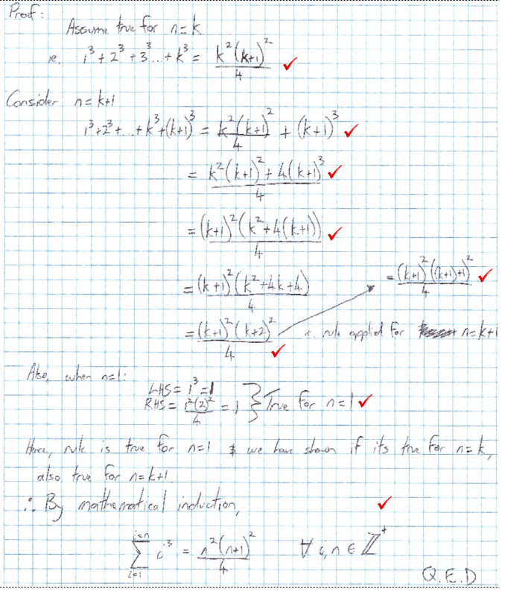

[8 Marks]

- For the equation $x^{3}-1=0$





  - Show that $x=\frac{-1-i\sqrt{3}}{2}$ is a complex solution.
$${\left(\frac{-1-i\sqrt{3}}{2}\right)}^{3}-1$$
$$=\frac{\left(-1-i\sqrt{3}\right)\left(-1-i\sqrt{3}\right)\left(-1-i\sqrt{3}\right)}{8}-1$$
$$=\frac{\left(-1-i\sqrt{3}\right)(-2+2i\sqrt{3})}{8}-1$$
$$=\frac{2-2i\sqrt{3}+2i\sqrt{3}-6i^{2}}{8}-1$$
$$=\frac{8}{8}-1=0=RHS$$
$$∴x=\frac{-1-i\sqrt{3}}{2} is a solution$$




  - Determine the other two solutions to the equation $x^{3}-1=0$and hence factorise $x^{3}-1$.
$$Complex conjugate of x=\frac{-1+i\sqrt{3}}{2} is another solution$$
$$Also, x=1 is a solution.$$
$$∴x^{3}-1 factorises to$$
$$\left(x-1\right)\left( x-\frac{-1-i\sqrt{3}}{2}\right)\left(x-\frac{-1+i\sqrt{3}}{2} \right) or$$
$$\left(x-1\right)\left( x+\frac{1+i\sqrt{3}}{2}\right)\left(x+\frac{1-i\sqrt{3}}{2} \right)$$
[5,3 = 8 Marks]

- Sketch the complex numbers as vectors on the Argand Diagram below.
$$z_{1}=1-2i, { z}_{2}=\frac{3}{-i}, { z}_{3}=i^{7}z_{1}, { z}_{4}=\overline{z_{2}}, { z}_{5}=\frac{1}{9}z_{1}z_{2}z_{3}z_{4}$$
$$z_{2}=\frac{3i}{-i^{2}}=3i$$
$$z_{3}=-i\left(1-2i\right)=-i-2$$
$$z_{4}= -3i$$
$$z_{5}=\frac{1}{9}(1-2i)(3i)(-i-2)(-3i)$$
$$=\frac{1}{9}-9i^{2}(1-2i)(-i-2)$$
$$=\left(-i-2+2i^{2}+4i\right) ∴z_{5}=(-4+3i)$$
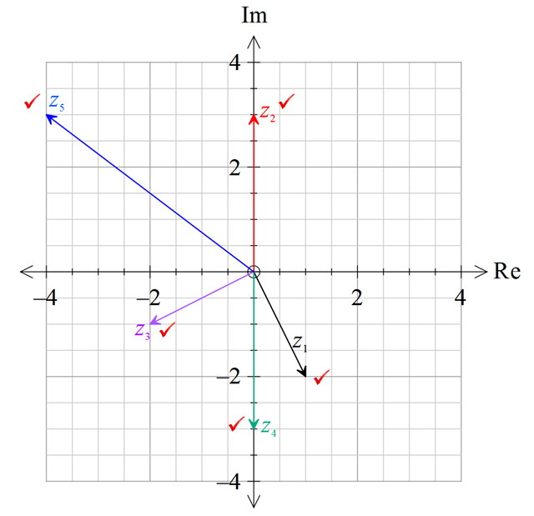
[5 marks]



- Complete the square to express $x^{2}+14x+53$ as a product of linear factors.
$${=\left(x+7\right)}^{2}-49+53$$
$$={\left(x+7\right)}^{2}+4$$
$$={\left(x+7\right)}^{2}-{\left(2i\right)}^{2}$$
$$=(x+7-2i)(x+7+2i)$$
[3 marks]

- For the Argand Diagrams below:
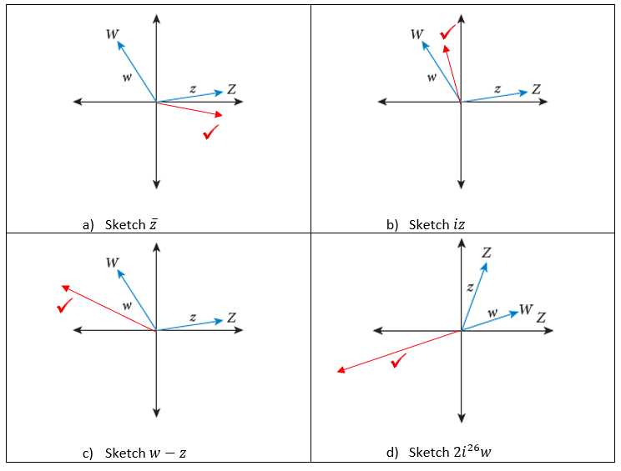

[4 marks]





- Convert the decimal $2.40\overline{7}$ into the form $\frac{a}{b}, a,b∈ Z^{+}$ where $a and b$ are coprime.
$$Let x=2.40\overline{7}$$
$$100x=240.\overline{7}$$
$$1000x=2407.\overline{7}$$
$$900x=2167$$
$$x=\frac{2167}{900}$$

[4 marks]
- By exhausting all possible cases, prove that there are no rational solutions to the equation:
$$x^{3}+x+3=0$$
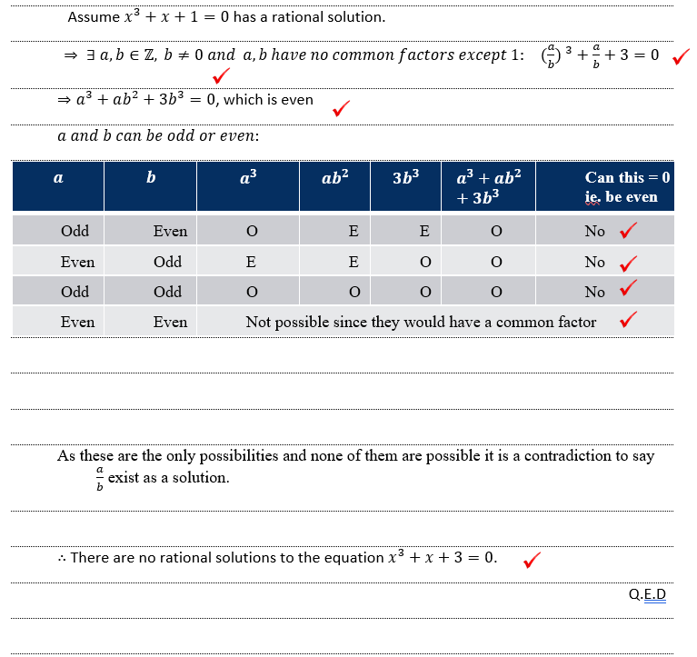
[8 Marks]

*** End of Test ***
***Extra space for working out***
